Merge sort algorithm walkthrough and divide-and-conquer technique explanation
Wed, 22 Apr 26
Merge Sort Overview
- Sorting technique with different characteristics from other methods
- Uses divide and conquer approach
  - Divide collection into smaller subsets
  - Recursively solve subsets
  - Combine results into final solution
Divide and Conquer Process
- Example: 6 barrels sorted by weight
- Initial division into two halves of 3 barrels each
- Left half process:
  - Divide 3kg, 5kg, 8kg into subsets
  - Single elements considered sorted (3kg standalone)
  - Merge 5kg and 8kg first
  - Merge 3kg with sorted 5kg-8kg subset
- Right half process:
  - Divide 9kg, 6kg, 2kg into subsets
  - 9kg standalone already sorted
  - Divide 6kg-2kg into individual elements
  - Merge 2kg and 6kg first
  - Merge 9kg with sorted 2kg-6kg subset
Merging Algorithm
- Compare first elements from left and right subsets
- Select smaller element for merge
- Move to next element in subset where element was taken
- Detailed example sequence:
  - Compare 3kg vs 2kg → merge 2kg first
  - Compare 3kg vs 6kg → merge 3kg
  - Compare 5kg vs 6kg → merge 5kg
  - Compare 8kg vs 6kg → merge 6kg
  - Compare 8kg vs 9kg → merge 8kg
  - Merge remaining 9kg
- Result: elements in sorted order
Tree Visualization
- Visual representation shows recursive division structure
- Leaves represent single elements (already sorted)
- Internal nodes show merge operations
- Bottom-up merging creates final sorted sequence
- Demonstrates complete divide and conquer workflow
Merge sort algorithm walkthrough and recursive implementation steps
Wed, 22 Apr 26
Merge Sort Algorithm Overview
- Recursive divide-and-conquer algorithm with three parameters:
  - Array to be sorted
  - Left index (leftmost position)
  - Right index (rightmost position)
- Core condition: continues while left index < right index
- Stops when subset contains only one element
Divide Process Implementation
- Calculate mid index: (left + right) / 2
  - Use floor value for integer indices
  - Example: (0 + 5) / 2 = 2.5 → mid = 2
- Recursive calls split array into two halves:
  - mergeSort(array, left, mid)
  - mergeSort(array, mid + 1, right)
- Process continues until each subset has single element
Step-by-Step Execution Example
- Initial array with left=0, right=5
- First division: mid=2, creates subsets [0-2] and [3-5]
- Left subset [0-2] further divided:
  - Mid=1, creates [0-1] and [2-2]
  - [0-1] divided to [0-0] and [1-1]
- Base case reached when left ≥ right (single elements)
- Same recursive pattern applied to right subset
Merge Algorithm Integration
- Called after recursive divisions complete
- Merges two sorted subsets back together
- Parameters: array, left index, mid index, right index
- Combines elements 3 and 5 first, then continues merging larger subsets
- Final step merges all sorted portions into complete sorted array
Merge algorithm walkthrough for sorted array merging
Wed, 22 Apr 26
Merge Algorithm Overview
- Merges two sorted arrays/subsets into single sorted array
- Takes 4 parameters:
  - Array to merge
  - Left index (leftmost position)
  - Mid index (middle position)
  - Right index (rightmost position)
Algorithm Variables & Setup
- Variable i: points to left index (starts at index 0)
- Variable j: points to mid+1 index (handles second subset)
- Variable k: index for temporary array B (stores merged elements)
- Array B: temporary storage for final merged result
Step-by-Step Execution Process
- Main while loop compares elements from both subsets
  - Condition: i ≤ mid AND j ≤ right
  - If a[i] < a[j]: store a[i] in array B, increment i and k
  - Else: store a[j] in array B, increment j and k
- First cleanup loop: handles remaining elements from left subset
  - Executes when right subset fully processed
- Second cleanup loop: handles remaining elements from right subset
  - Executes when left subset fully processed
- Final copy loop: transfers all elements from array B back to original array A
Algorithm Completion
- Results in fully sorted merged array
- Next video will cover merge sort complexity analysis
Merge sort algorithm time complexity analysis
Wed, 22 Apr 26
Merge Sort Algorithm Overview
- Recursive algorithm that calls itself and merge function
- Divides elements into subsets, sorts recursively, then merges results
- Process continues until all subsets contain single element (considered sorted)
Merge Algorithm Complexity
- Copies one element at a time from left/right subsets to new array
- Running time: O(n) where n = n1 + n2 (elements in both subsets)
- Makes n1 + n2 comparisons in while loop iterations
Merge Sort Time Complexity Analysis
- Division process creates levels with subset counts:
  - Level 0: 1 subset (2^0)
  - Level 1: 2 subsets (2^1)
  - Level 2: 4 subsets (2^2)
  - Level 3: 8 subsets (2^3)
  - Continues to 2^n subsets
- Total levels: log₂(n)
- Overall complexity: O(n log n)
  - Merge algorithm O(n) × log n levels = O(n log n)
Next Steps
- Implementation of merge sort algorithm covered in following video
Alright—this is where things get interesting. Merge Sort is very different from the previous sorts: it doesn’t swap or shift locally… it divides first, then merges in order.
I’ll structure this exactly like before:
- Concept + full step-by-step (graphical thinking)
- Clean combined code (your version, properly structured)
- Line-by-line explanation (both functions)
- Time & Space complexity

🧠 Merge Sort — “Divide → Sort → Merge”
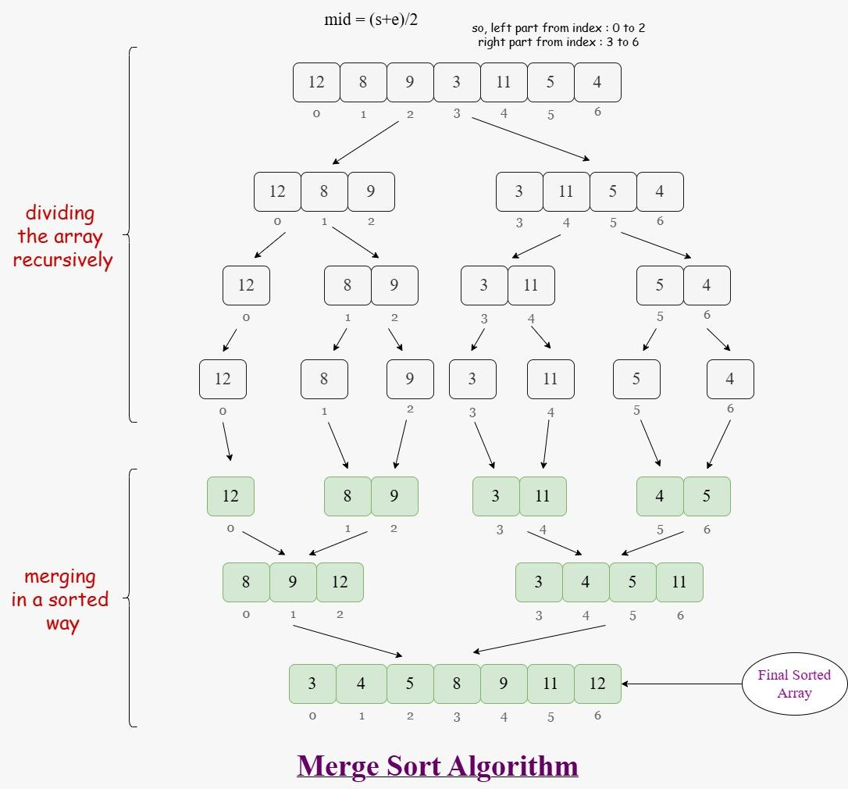
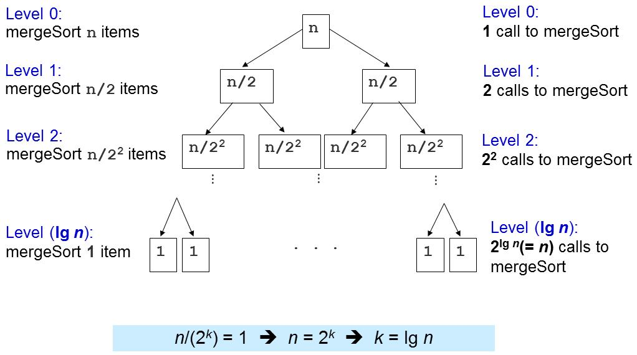
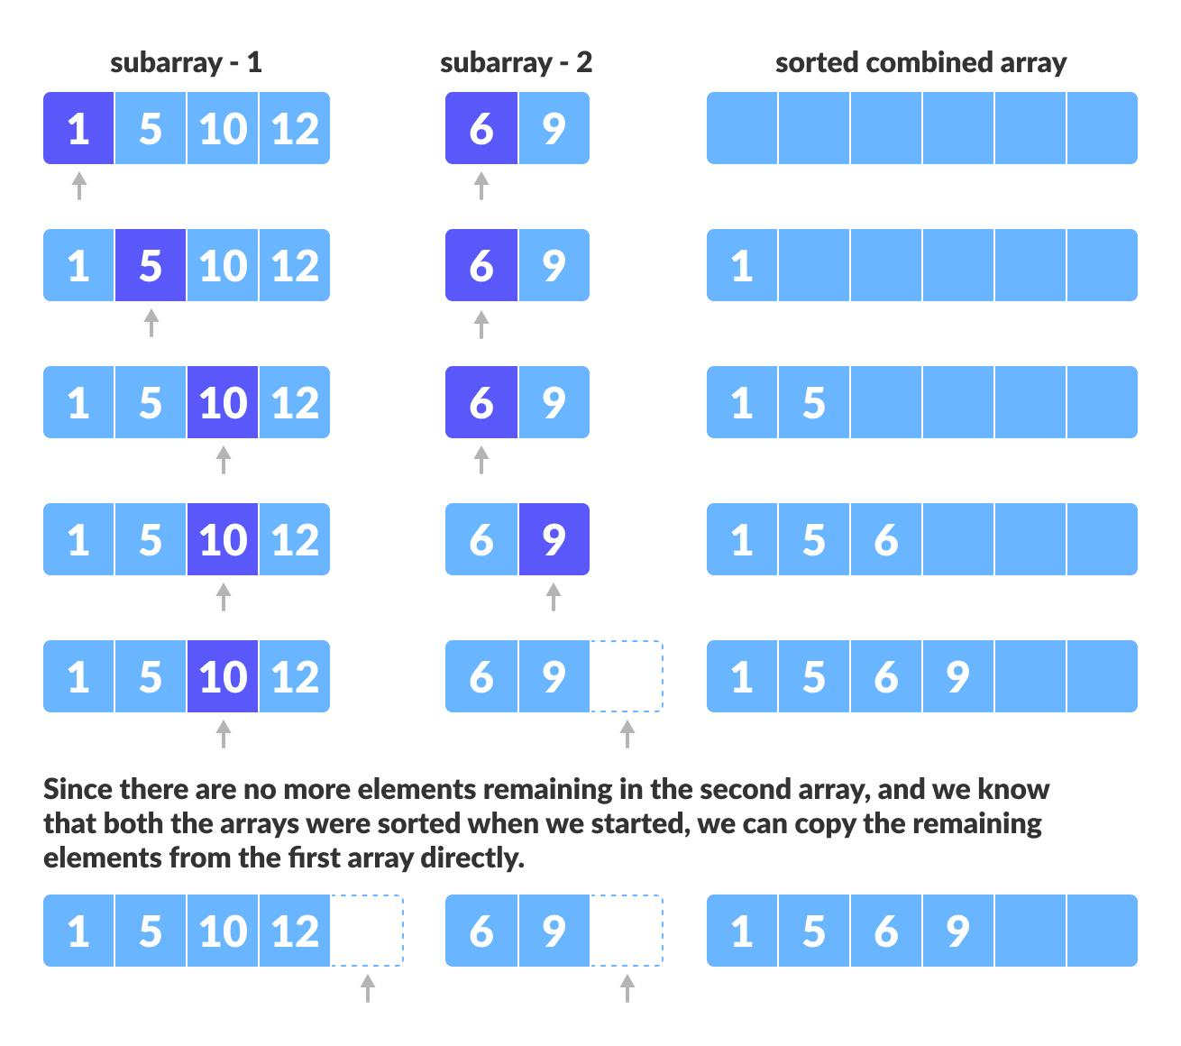
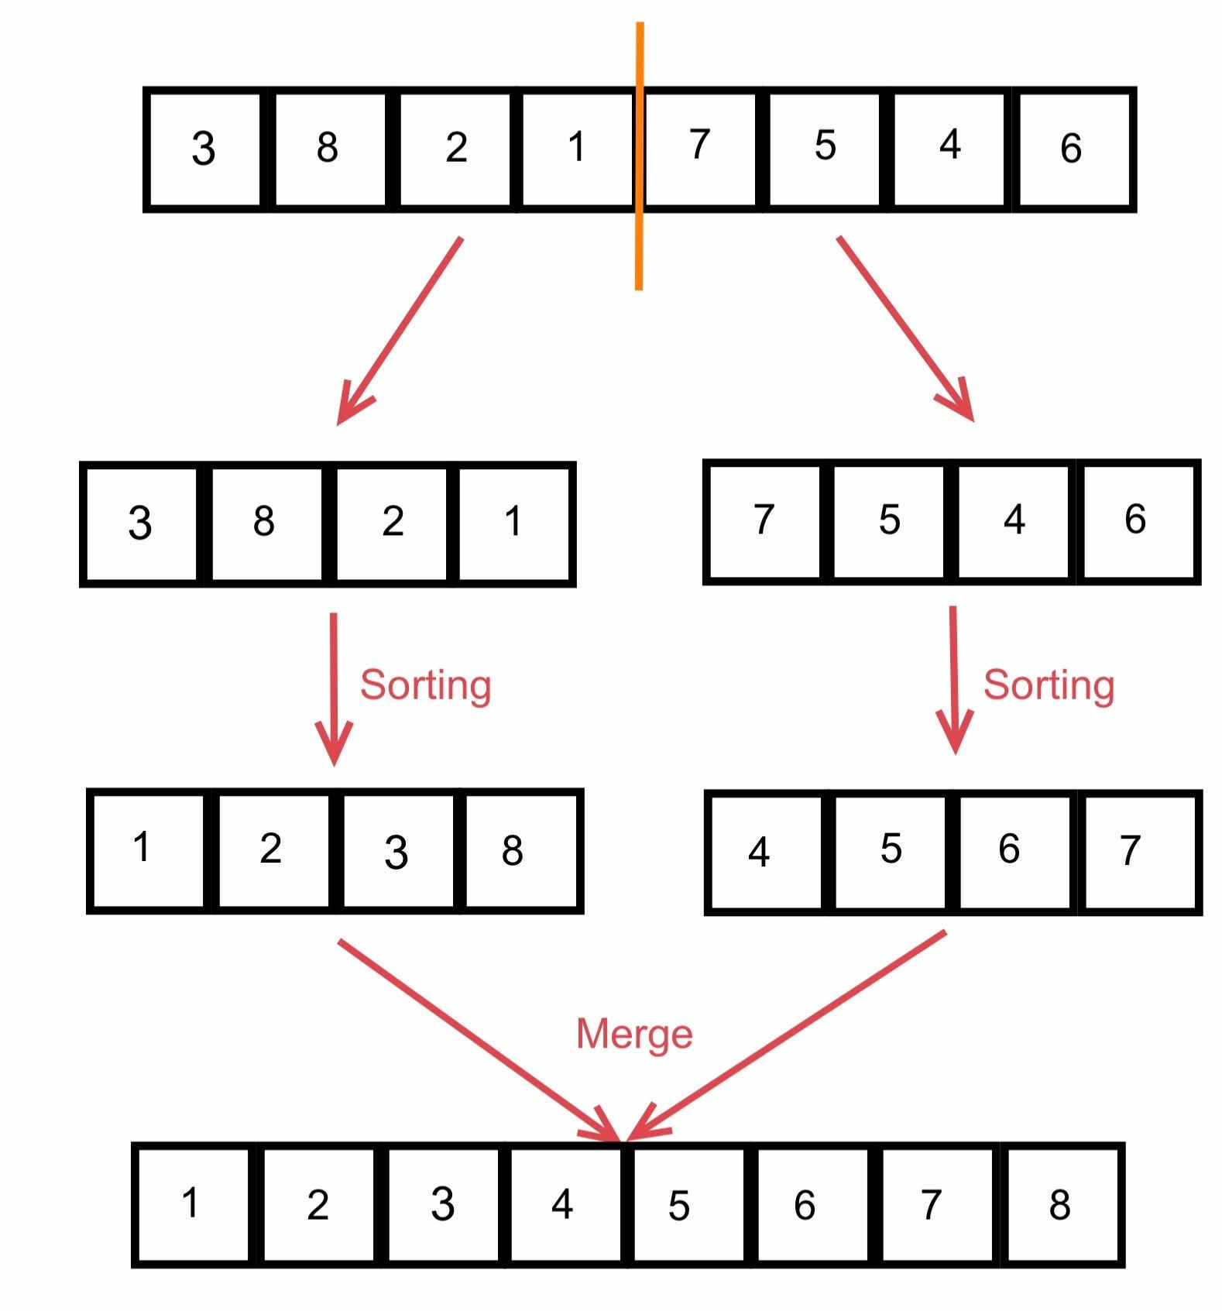
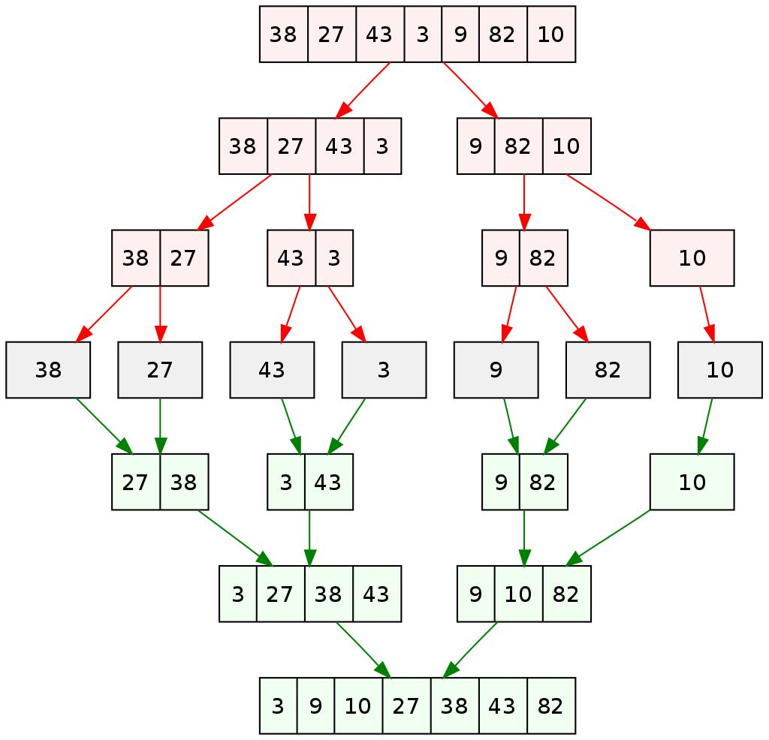
💡 Core Idea
- Divide array into halves
- Keep dividing until single elements
- Merge them back in sorted order
👉 This is called Divide and Conquer

🔄 PART 1: Step-by-Step Execution
Take:
[64, 25, 12, 22, 11]

🔹 Step 1: Divide
[64, 25, 12, 22, 11]
↓
[64, 25, 12] [22, 11]

🔹 Step 2: Keep Dividing
[64, 25, 12] → [64] [25, 12]
[25, 12] → [25] [12]

[22, 11] → [22] [11]

🔹 Step 3: Merge Small Parts
Merge [25] & [12]
→ [12, 25]
Merge [64] & [12, 25]
Compare:
64 vs 12 → 12
64 vs 25 → 25
Remaining → 64

→ [12, 25, 64]

Merge [22] & [11]
→ [11, 22]

🔹 Step 4: Final Merge
[12, 25, 64] + [11, 22]

Compare:
12 vs 11 → 11
12 vs 22 → 12
25 vs 22 → 22
Remaining → 25, 64

→ [11, 12, 22, 25, 64]
✔ Sorted!

🧾 PART 2: Clean Combined Code (Your Version Fixed)
public void mergesort(int[] A, int left, int right)
{
if (left < right)
{
int mid = (left + right) / 2;

mergesort(A, left, mid);
mergesort(A, mid + 1, right);

merge(A, left, mid, right);
}
}

public void merge(int[] A, int left, int mid, int right)
{
int i = left;
int j = mid + 1;
int k = left;

int[] B = new int[right + 1];

// Merge both halves
while (i <= mid && j <= right)
{
if (A[i] < A[j])
{
B[k] = A[i];
i++;
}
else
{
B[k] = A[j];
j++;
}
k++;
}

// Remaining left half
while (i <= mid)
{
B[k] = A[i];
i++;
k++;
}

// Remaining right half
while (j <= right)
{
B[k] = A[j];
j++;
k++;
}

// Copy back to original array
for (int x = left; x <= right; x++)
{
A[x] = B[x];
}
}

🔍 PART 3: Code Explanation

🔹 A. mergesort() Function (Divide Phase)

1. Base Condition
if (left < right)
👉 Stop when:
- Only one element remains

2. Find Middle
int mid = (left + right) / 2;
👉 Split array into:
- Left half
- Right half

3. Recursive Calls
mergesort(A, left, mid);
mergesort(A, mid + 1, right);
👉 Keep dividing until:
[64] [25] [12] [22] [11]

4. Merge Call
merge(A, left, mid, right);
👉 Combine sorted halves

🔹 B. merge() Function (Core Logic)

1. Initialize Pointers
int i = left;
int j = mid + 1;
int k = left;
👉 Think:
- i → left array
- j → right array
- k → new array position

2. Temporary Array
int[] B = new int[right + 1];
👉 Stores merged result

3. Compare and Merge
while (i <= mid && j <= right)
👉 Compare both halves:
if (A[i] < A[j])
👉 Pick smaller element

📦 Example:
[12, 25, 64] + [11, 22]
Step:
- 12 vs 11 → 11
- 12 vs 22 → 12

4. Remaining Elements
while (i <= mid)
while (j <= right)
👉 Copy leftover elements

5. Copy Back
for (int x = left; x <= right; x++)
A[x] = B[x];
👉 Replace original array

🧠 Mental Mapping
Variable | Meaning
left, right | current subarray
mid | division point
i | left pointer
j | right pointer
k | merged array index
B[] | temporary storage

📊 PART 4: Complexity Analysis

⏱ Time Complexity
T(n)=n\log n
Why?
- Divide → log n levels
- Merge → n work per level

💾 Space Complexity
O(n)
👉 Extra array B[] used

⚡ Key Insight
- Merge Sort is:
  - ✅ Stable
  - ✅ Predictable performance
  - ❌ Uses extra memory

🧩 Developer Insight
Compared to others:
Algorithm | Time | Space | Notes
Bubble | O(n²) | O(1) | simple
Insertion | O(n²) | O(1) | good for small
Shell | ~O(n^1.3) | O(1) | faster
Merge | O(n log n) | O(n) | scalable

🚀 Final Understanding
- First break everything
- Then build it back in order
👉 That’s why Merge Sort feels “backwards”… but is extremely powerful.

If you want next:
- I can show recursion tree diagram (very important for exams)
- Or compare Merge vs Quick Sort visually (high-value interview topic)

